


Experiment No.: 3

Title

Water Jug Problem using Python

Aim

To solve the Water Jug Problem using Python.

Apparatus / Software Required

Computer or Laptop

Python 3.x

IDLE / VS Code / PyCharm (Any Python IDE)

Windows Operating System

Procedure

Open the Python IDE.

Create a new Python file.

Write the Python program for the Water Jug Problem.

Save the file with the .py extension.

Run the program.

Enter the jug capacities and target amount (if required).

The program performs the water transfer operations.

Display the steps to reach the target quantity.

Verify the output.

Close the program.

Program

from collections import deque

def water_jug(a, b, target):

visited = set()

q = deque([(0,0)])

while q:

x, y = q.popleft()

if (x,y) in visited:

continue

visited.add((x,y))

print((x,y))

if x == target or y == target:

print("Target Reached")

return

q.extend([

(a,y),

(x,b),

(0,y),

(x,0),

(max(0,x-(b-y)), min(b,x+y)),

(min(a,x+y), max(0,y-(a-x)))

])

water_jug(4,3,2)

Sample Output

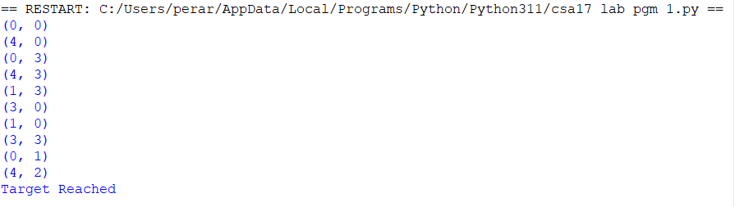

Result

Thus, the Python program to solve the Water Jug Problem was implemented successfully, and the required target quantity was obtained.

